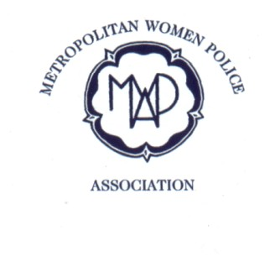
Metropolitan Women Police Association Founded 1976

APPLICATION Form:
Last name: | First name:
Previous names: | Date of birth:
Address: | Phone Numbers:  Home:  Mobile:  Email:  Face Book User: (Secure Site for Members only) Yes or No
Warrant Number. Four or Six warrant numbers: | Alternative emergency contact number: (friend, family or neighbour)
☐ I attach a cheque for £15 payable to the MWPA.  ☐ I will pay by BACS.(see below)  Note.Subs for subsequent years are £10 | Stations and Departments worked:
How did you hear about the MWPA?  Name? | Dates of joining and leaving the Met:  Joined:  Left:
☐ Please enrol me as a member of the Metropolitan Women Police Association.  ☐ I agree that the MWPA manage my Data in line with the General Data Protection Regulations (25.5.2018) | Signature:  Date:
Note: - Newsletters are sent by email unless advised otherwise, i.e. no computer access.
- A welcome pack including your membership number will be posted to you.
- If using BACS, Metropolitan Woman Police Association, Sort Code is 090154, Account No.12343908. Please quote your membership number and surname where possible.
Please send to MWPA,Pinelands, Nyetimber Copse, West Chiltington, West Sussex. RH20 2NE
FOR OFFICE USE ONLY | Bank transfer received:
Membership number: | On database:
Email sent: | Pack sent:

